PNEUMONIA DETECTION USING DEEP LEARNING
Scope and Limitations
Department of Computer Science and Engineering, TKR College of Engineering and Technology (Autonomous)
Batch A12 (CSE-A) · Academic year 2026-2027
Table 1: Project team
S.No. | Student name | Roll number
1 | CHOUDAM AKSHITHA | 23K91A0556
2 | BOGGULA SATVIK KUMAR | 23K91A0541
3 | ARUTLA ABHI THEJ REDDY | 23K91A0515
4 | DUGGARAJU LIKHITHA | 23K91A0565

Project guide: V. MEENAKSHI
Chapter and section numbers quoted in the text (for example Section 6.6 or Chapter 8) refer to the full project report, 17.Final Document. Figures and tables in this document are numbered from 1.

1. SCOPE

1.1 In scope
Table 2: In scope
# | Item
1 | Three-way classification of a single frontal chest X-ray into Normal, Bacterial Pneumonia or Viral Pneumonia, with per-class probabilities.
2 | The preprocessing chain actually used in the code: grayscale decoding, resizing to 224 x 224, CLAHE contrast enhancement, light Gaussian smoothing and scaling to [0, 1].
3 | A convolutional network written for the project (four convolution blocks, global average pooling and a dense head), plus a transfer-learning builder for DenseNet, ResNet and EfficientNet backbones.
4 | A Grad-CAM heatmap overlay for the predicted class on every scan.
5 | A web application with a React front end, a FastAPI service and the original Flask interface, a signed-cookie demo login, SQLite history, a dashboard, CSV export and deletion of stored scans.
6 | A reproducible training and evaluation script, an automated test suite and the documentation set.

1.2 Out of scope
Table 3: Out of scope
# | Item
1 | U-Net lung segmentation. It is an objective of the project proposal, but no segmentation network is implemented, trained or evaluated; the classifier sees the whole radiograph.
2 | Clinical use. The system is a research prototype for screening support and has not been validated on patients, by radiologists or by any regulator.
3 | Any imaging modality other than frontal chest X-rays, any disease other than pneumonia, and adult or non-paediatric validation (the training data are paediatric).
4 | DICOM handling, PACS or hospital information system integration, multi-user accounts, role management and audit logging.
5 | Semi-supervised learning, Monte Carlo Dropout uncertainty and external multi-hospital validation, which the base paper studies and this project does not reproduce.
6 | Cloud deployment, containerisation and horizontal scaling.

The boundary is deliberate. The system is a screening-support prototype whose predictions are always accompanied by a heat map and a disclaimer; anything that would make it a clinical tool (regulatory approval, validation on patients, integration with hospital systems) is outside the project.
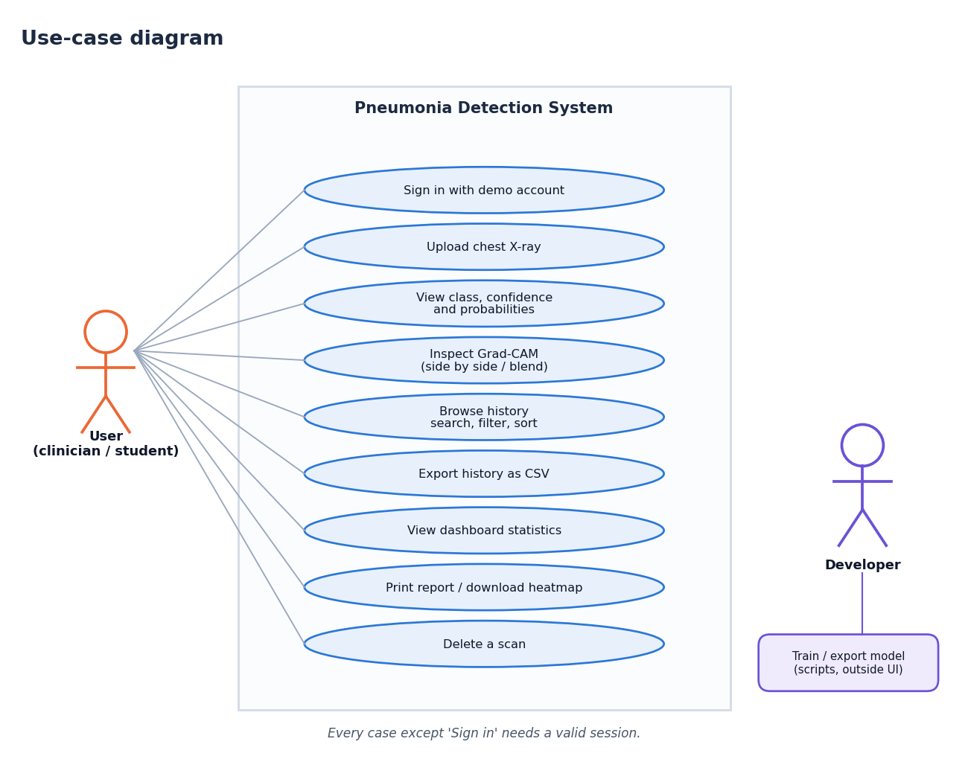
Figure 1: What the user can do within the scope of the system (use-case diagram)

2. ASSUMPTIONS
• The uploaded image is a frontal (PA or AP) chest radiograph in PNG or JPEG form and no larger than 8 MB.
• The public Kermany dataset is representative enough of paediatric chest X-rays to demonstrate the pipeline; its labels are taken as ground truth.
• Bacterial and viral labels are derived from the file names of the dataset (person_bacteria_, person_virus_), as the original authors encoded them.
• A single trusted user population: the demo login is a convenience, not an identity system.
• The machine running the system has Python 3.10 or 3.11, Node.js 18 or newer and about 2 GB of free disk for the Python environment.

3. LIMITATIONS
• No U-Net segmentation. One of the six stated objectives was not met; the model may use image regions outside the lungs, and the Grad-CAM maps in Chapter 8 show that it sometimes does.
• Single data source. All training and test images come from one paediatric centre. The official test split is known to differ in distribution from the training split, and no external hospital data were available, so the reported figures say little about performance elsewhere.
• Modest absolute accuracy. Normal radiographs are often called pneumonia and the two pneumonia types overlap on a radiograph alone; the confusion matrix in Chapter 8 shows where the model fails.
• CPU-only training. All training was run on a desktop CPU (no GPU), which limited the number of experiments and made large backbones impractical.
• Class labels from file names. Pathogen type is not independently verified by the authors of this project.
• Uncalibrated probabilities. Confidence is the raw softmax output; no temperature scaling or Monte Carlo Dropout is applied, so a high confidence is not a guarantee of correctness.
• Security is demonstration-grade. A single shared demo account, an HMAC-signed cookie and an HTTP-only transport; the original Flask application still uses a fixed secret key and offers no login.
• Not a medical device. Outputs must not be used as the sole basis for diagnosis or treatment.
Evidence from the measurements. The three-class accuracy on the official test split is 79.5%, and the recall of the weakest class is 62.0%. The expected calibration error is 0.033. These figures come from one seed and one data source and carry no confidence interval.
Table 4: Risks and mitigations
Risk | Mitigation in the project
Output mistaken for a diagnosis | Disclaimer on every screen and in the README; Demo Mode alert for untrained models; heat map shown with every prediction
Over-confident wrong prediction | Confidence shown with the full probability bars; threshold analysis in Chapter 8; recommendation to review low-confidence scans
Distribution shift (other hospitals, adults) | Stated as a limitation; no claim beyond the public paediatric data
Test-set overlap inflating results | Patient-disjoint subset and patient-level re-partition reported beside the official split
Unauthorised access | Signed HttpOnly cookie, 401 on protected routes; demo account only, no real patient data should be loaded

4. WHAT WAS NOT MEASURED
The following were not measured and are therefore stated as gaps, not estimated:
• Run-to-run variation (confidence intervals): each configuration was trained once with seed 42.
• Performance on any data source other than the Kermany paediatric dataset.
• Agreement with radiologists, or any human-factors or usability study with clinicians.
• Load, concurrency and long-running behaviour of the API beyond the single-inference lock.
• The effect of U-Net segmentation, Monte Carlo Dropout or semi-supervised learning, which were not implemented.
• The effect of horizontal-flip augmentation (the base paper disables it); the shipped augmentor was used unchanged.
• Browsers other than Chromium and any assistive technology for the user-interface checks.

